About Bodø
Bodø is the gate to the arctic: located at 67º north, north of the polar circle, north of Iceland and even north of the populated areas in Greenland.
Bodø was founded in 1816 and last year the city celebrated their 200 years anniversary.
The town grew slowly in the beginning, but now it is one of the fastest growing cities in Norway. Today the city has 50.000 inhabitants.
During the Second World War 80 % of the buildings were destroyed, so you want find many old buildings in the town center, but today the city appears as an urban and modern city with beautiful surroundings. In 2016 Bodø was named the most attractive city in Norway.
Bodø is the administration center in the county of Nordland.
The tourism is increasing in Bodø, a lot of the tourist want to experience the wild nature. Soft adventures has become more and more popular with kayaking and mountain hiking.
A lot of festivals and exhibitions are being arranged through out the year.
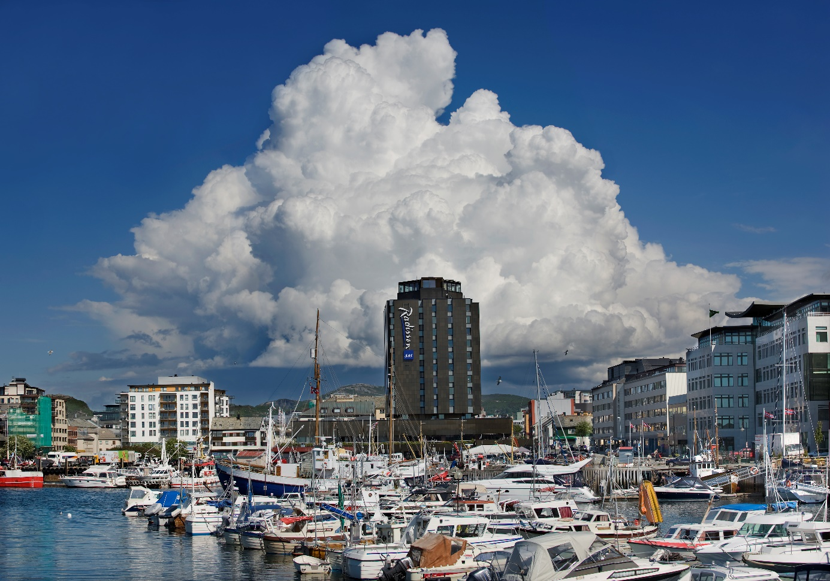
Photo: Ernst Furuhatt/Visit Bodø

The light
From 4th of June until 8th of July you can see the midnight sun in Bodø, and in the winter you can see the northern light (Aurora borealis).
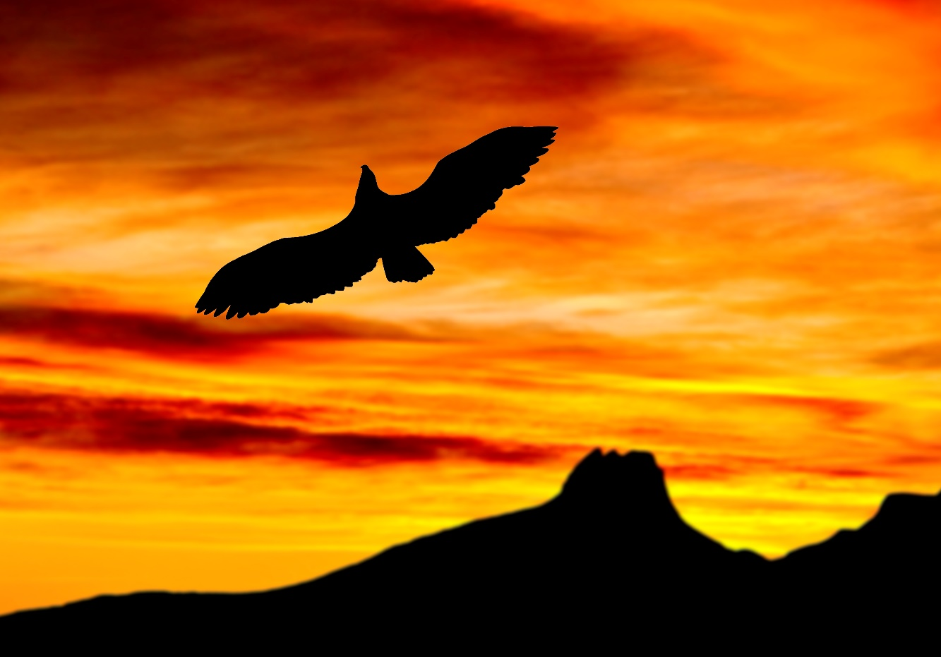
Photo: Rune Nilsen/Visit Bodø
What to do in Bodø
The city center is quite compact, and a walk in the city center and along the pier and breakwater is recommended.
The library in the middle of the city center is a fantastic building, and quite new – worth a visit.
You can also find several great street-art pictures, some of them are very big. You can have a map at the main secretariat or read more here: http://bodo2016.no/prosjekter/upnorth-article711-167.html
The National Aviation Museum with aviation history (both civil and military)
You can visit one of our beautiful beaches.
If you want to learn more about our history you can visit the Norlandsmuseum. You find it next to the big cathedral in the city center.

Practical
- Map of Bodø: https://kart.gulesider.no/?index=yp&query=kart%20bod%C3%B8
- Wind: Bodø the windy city – always – bring a jacket!
- There are walking distances in the city center where you can find all the hotels.
- The tap water is very clean, and you can drink it.
- Central European Summer Time (CEST) is 2 hours in front of UTC.
- The average temperature in September is 9 degrees Celsius.
- The currency in Norway is Norwegian kroner. (100 NOK is about 105 SEK, 957 RUB and 11 €)
- Electricity: 220V
- The language is Norwegian and here are some words:
Thank you = takk
Hello = hei
Goodbye = hade
My name is… = jeg heter ……
How to get to Bodø
Getting to Bodø is easy and there are several options. You can travel here by air from the north, south, east or west. The airport is located only one kilometre away from the city centre, and is just a ten minutes’ walk. You can also arrive on the
northbound or southbound Hurtigruten (the Norwegian Costal Voyage) and continue your journey by water in the beautiful region of Nordland by express boat or ferry. You can drive here along the picturesque Kystriksveien (The Costal Route) which
is Norway’s longest National Tourist Route called Helgelandskysten, or arrive by train via the Saltfjellet mountain range where you cross the Arctic Circle. Our own Polar Express has its final stop in Bodø, which is the railway terminal in Northern Norway.

Safety

Bodø is a safe city with low rate of street crime, but as always when you are travelling: take good care of your valuables, and don’t keep anything in the warderobes.

Alcohol

It is strictly forbidden to use alcohol or any kind of drugs in addition to Barents Summer Games. If this happen it will have consequences both for the athlete and the team.

Passport

The leader for each team must take care of all the passports. The passports can be delivered at the hotel for safe storage.

