



**19th Masters in Denmark**

**18th of June to 21th of June 2020**

**International Rifle Competition**

The Shooting Club DSB/ASF in Aarhus hereby has the great pleasure of inviting rifle shooters to the above mentioned event.

**Site:** Skydebaneforeningen Vestereng

Vesterengvej 26

8200 Aarhus N

Denmark

Coordinates N 56011’04,83

E 10010’48,83

**Targets:** 50 meter30 firing points Sius

10 meter 53 firing points Sius

**Disciplines:** 60 shoot prone + 3x40 male+female Freerifle

60 shoot male+female Airrifle

**Entry fees:** Per shooter for all 3 competition days **DKK 750,00**

**Awards:** Medals for the 3 best in all events every day.

3.000 DKK to number 1 in 60 prone and 3x40 men average 3 days

3.000 DKK to number 1 in 60 prone and 3x40 female average 3 days

3.000 DKK to number 1 in 60 airrifle male and female average 3 days

**A total of MINIMUM DKK 18.000 in awards in 2020.**

The winners must be present during the victory ceremony otherwise the prices will be awarded to the next shooter present.

You may use your on prone mats according to Technical Rules 6.3.12.2.2 except the last sentence.

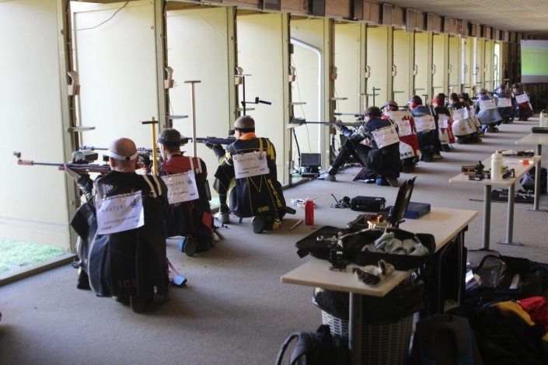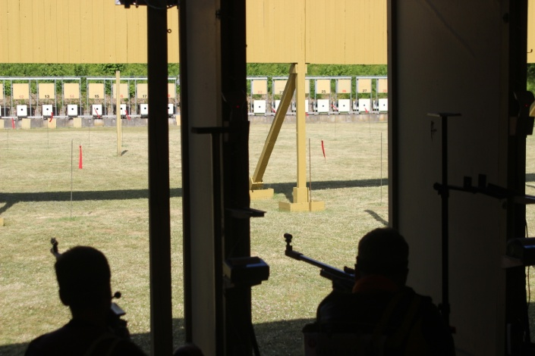

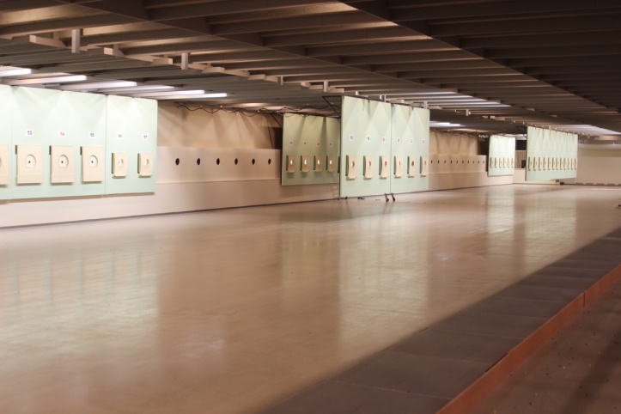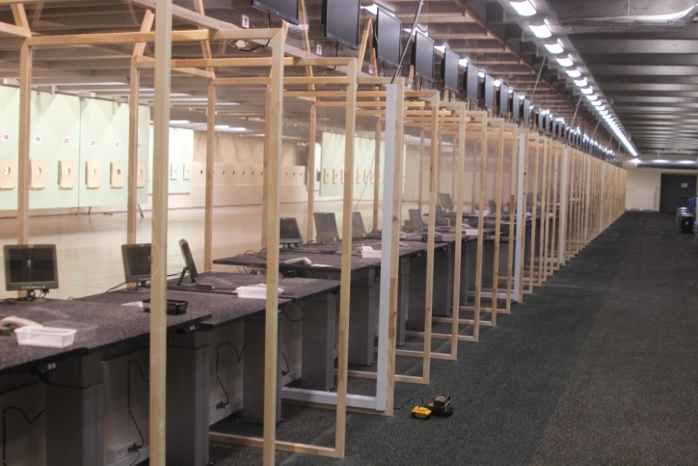

**Accommodation book please direct at the Hotel.**

**We would suggest the following hotel:**

Scandic hotel www.scandichotels.dk/hoteller/danmark/aarhus

**Self booking other hotels/room** [www.visitaarhus.com](http://www.visitaarhus.com)

[www.booking.com](http://www.booking.com)

**Inscription:** Final entry form Mai 1th 2020.

**Transport:** Transport during the competition per person DKK 500,-

**Payment**:

Payment **must be made** before registration is accepted.

Entry fee must be made to our bank connection

Bank name and address Nordea, Aarhus

Club name Skytteklubben DSB/ASF

Account no. IBAN: DK5120000267120110

SWIFT Code: NDEADKKK

For Danish payment must be used: 2264 0267120110

All payment must be in DKK.

**Further details available by contacting:**

**finn@fiber.dk**

**Phone +45 22907162**

Please return the entry form properly filled in not later than **May 1th 2020**

Best regards

Finn Danielsen

Organizing Committee

**PROGRAMME**

**18th of June to 21th of June 2020 in Denmark**

All starting times are 1. competition shot

June 18th Thursday Arrival

Training 10 + 50 meter 12.00 - 16.00

Technical meeting (50 m range) 15.30

June 19th - 21th All days 1st + 2st + 3st course 10 and 50 meter range

1. Relay 40/40/40 male + female 8.00 - 10.45

2. Relay airrifle male + female 9.15 – 10.30

3. Relay 60 prone male + female 11.40 - 12.30

4. Relay 40/40/40 male + female 13.25 – 16.10 5. Relay airrifle male + female 14.15 - 15.30

6. Relay 60 prone male + female 17.05 – 17.55

Finale Airrifle 16.25

Final 3x40 male+female 18.45

Victory Ceremony 20.15

**Can be changed**

**Final entry form**

**Country: ________________________________________**

Club: ________________________________________

Contact person: ________________________________________

Address: ________________________________________

E-mail address: ________________________________________

Telephone: _______________

**Participation**

Please fill out the next page of information and return these two sides

Numbers of officials: _______

**Transport**

Car: _________ Flight: _________

Transport from Aarhus Airport and during the competition: _________

**Please return this not later than 1th May 2020 to**:

**Skytteklubben DSB/ASF**

**V/Finn Danielsen**

**Nattergalevej 11**

**DK-8210 Århus V**

**Denmark**

**Telephone +45 22907162**

**E-mail** [finn@fiber.dk](mailto:finn@fiber.dk)

**Please fill in names and shooting times**

