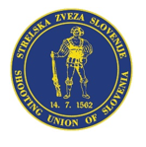

LAPUA EUROPEAN CUP
25 m PISTOL
26. - 28. 8. 2022
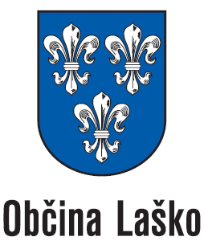
Laško / Slovenia

final HOTEL ENTRY FORM (mark the hotel you want with x)

Rates for rooms in Hotel Špica: Single room 54 € per night per person including breakfast

Double room 39 € per night per person including breakfast

Rates for rooms in Thermana Laško: Single room 75 € per night per person including breakfast

Double room 55 € per night per person including breakfast

Country: | Contact person:
Address: | Telephone:
E-Mail:

Name | Date for arrival | Date for departure | rooms
 |  |  | Double
 |  |  | Double
 |  |  | Double
 |  |  | Double
 |  |  | Double
 |  |  | Single
 |  |  | Single
 |  |  | Suite
We will confirm your reservation.
Please send this “Hotel Entry Form” NOT LATER THAN 01. August 2022 to the following E-mail address: andrej.brunsek@gmail.com

