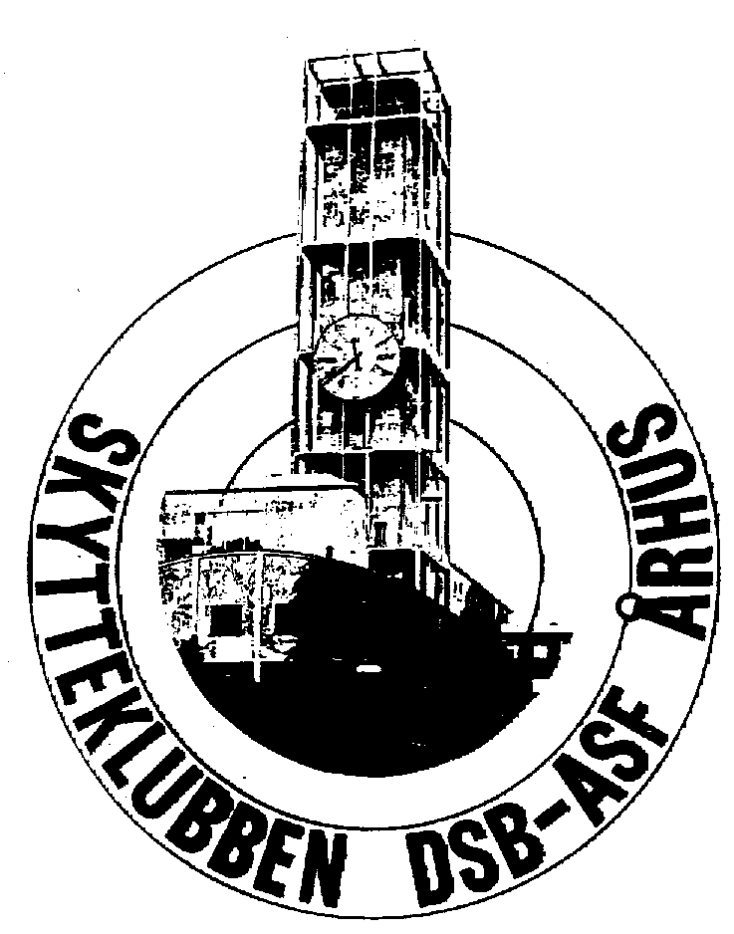
22^{thM A S T E R S}
Aarhus Denmark
27th of June to 30th of June 2024

^{M A S T E R S}
International Rifle Competition

Final entry form

Country: ________________________________________

Club: ________________________________________

Contact person: ________________________________________

Address: ________________________________________

E-mail address: ________________________________________

Telephone: _______________

Participation
Please fill out the next page of information and return these two sides

Numbers of officials: _______

Transport
Car: _________ Flight: _________

Transport from Aarhus Airport and during the competition: _________

Please return this not later than 30th May 2024 to:
Skytteklubben DSB/ASF
Att: Finn Danielsen
Nattergalevej 11
DK-8210 Århus V
Denmark
Telephone +45 22907162
E-mail finn@fiber.dk

Best regards
Finn Danielsen
finn@fiber.dk
Phone +45 22907162
Organizing Committee

