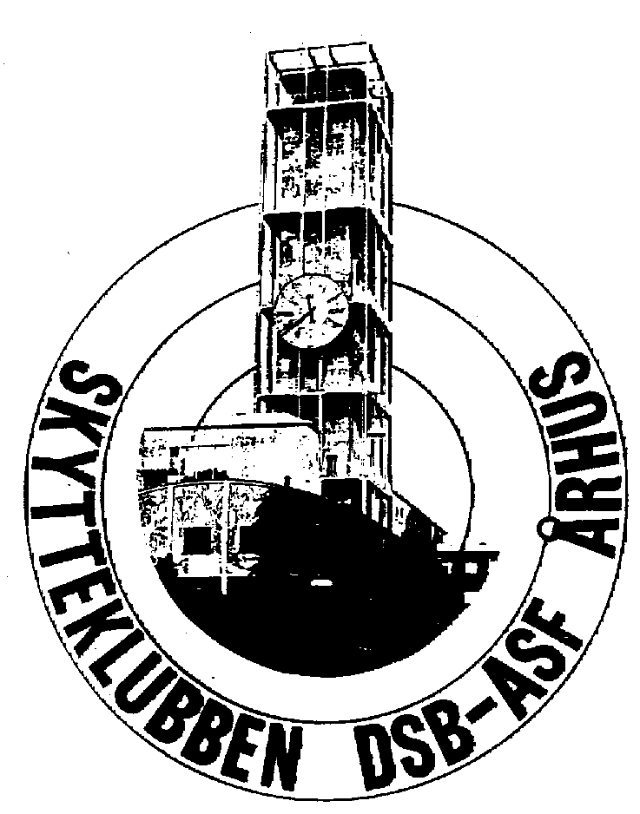
M A S T E R S
in Aarhus Danmark
27th of June to 30th of June 2024

International Rifle Competition
Please fill in names and shooting times
Only one start pr. Day in all disciplines

