 |  |  |  |  |  | 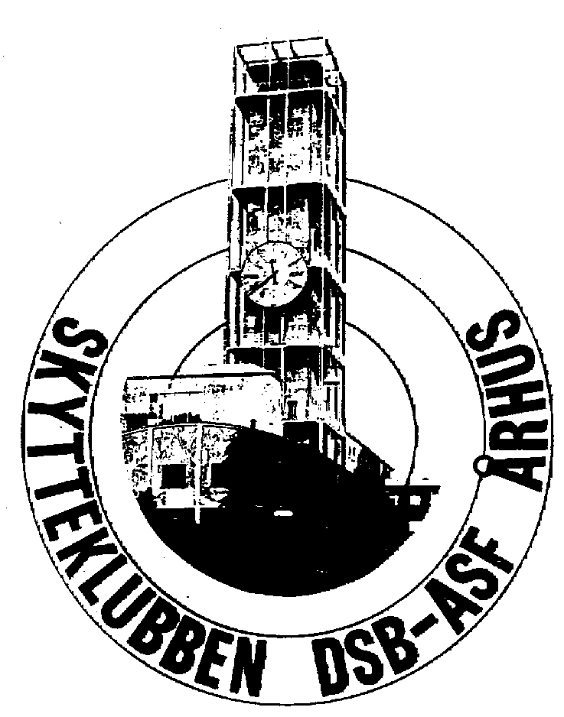
 |  |  |  | M A S T E R S
in Aarhus Danmark
12th of June to 15th of June 2025

International Rifle Competition
Please fill in names and shooting times
Only one start pr. Day in all disciplines

